Community Flood Risk Awareness and Preparedness Campaign
  - Activity Report • Hodaan IDP Site
Date: 13 October 2026
Location: Hodaan IDP Site, Dhobley District, Lower Juba, Jubbaland
Site population: 118 households
Participating stakeholders: Dhobley District Flood Prevention Committee, ISA Dhobley and Youth Caucuses

Executive summary
On 13 October 2026, the Dhobley District Flood Prevention Committee, in collaboration with ISA Dhobley and Youth Caucus representatives, conducted a community flood risk awareness and preparedness campaign at Hodaan IDP Site. The initiative shared practical safety messages with residents and emphasized early action, support for vulnerable people and coordination with local community structures.
Hodaan IDP Site accommodates 118 households. This figure describes the settlement population; the number of households or individuals reached by the campaign was not recorded in the information available for this report. Follow-up is needed to assess preparedness and identify households requiring additional support.
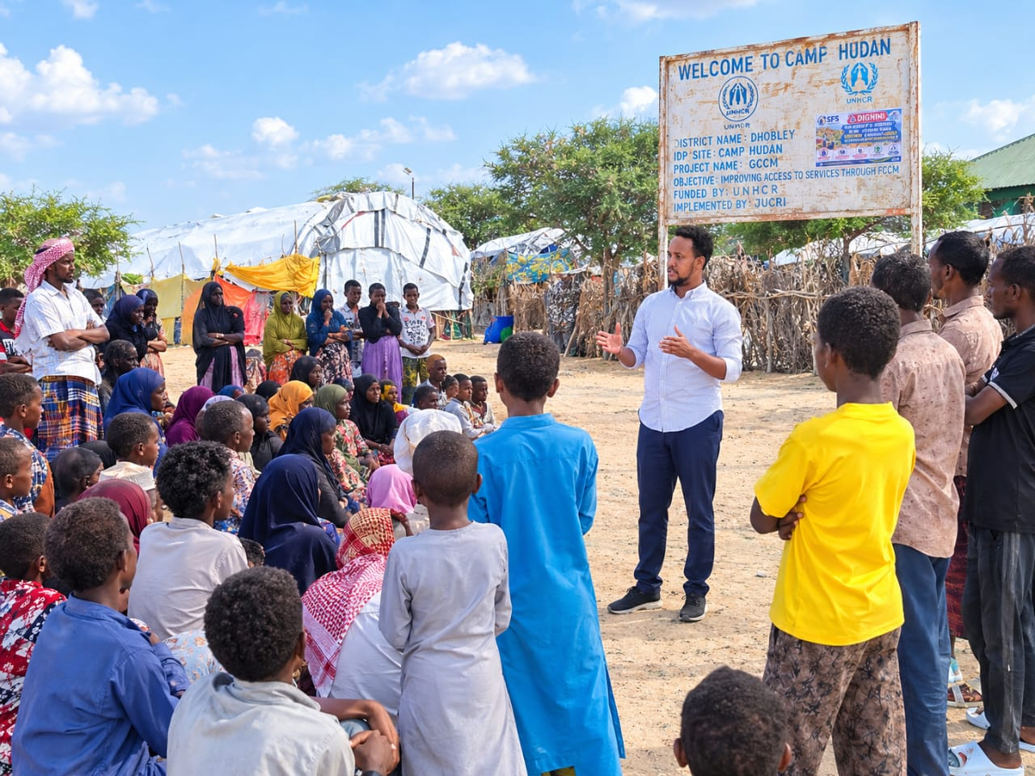
Photo 1. Community members gather for the flood awareness session at Hodaan IDP Site.

Background and purpose
The settlement was prioritized for sensitization to strengthen preparedness and reduce potential exposure to flood-related hazards. The campaign brought together local flood prevention structures and youth representatives to encourage collective responsibility for the safety of displaced households.

Objectives and awareness messages
The primary objective was to strengthen understanding of flood risks and promote practical actions before and during a potential emergency. Sensitization addressed five areas:
- Flood risk awareness. Remain vigilant, recognize flooding threats and avoid low-lying areas and unsafe water channels.
- Household preparedness. Plan early to protect family members, essential belongings and important documents.
- Protection and inclusion. Prioritize children, pregnant women, older persons, persons with disabilities and anyone requiring additional assistance.
- Early warning and information sharing. Follow weather alerts and information communicated by local authorities and community structures.
- Community cooperation. Work with residents, community leaders, youth representatives and the Flood Prevention Committee to communicate risks and support preventive action.

Community engagement and youth participation
Youth Caucus representatives supported community engagement and reinforced preparedness messages alongside the Flood Prevention Committee and ISA Dhobley. Their involvement highlighted the role of young people in community mobilization and locally led disaster preparedness. The joint activity also provided an opportunity to strengthen communication between residents and local stakeholders.

Immediate results and reporting limitations
The campaign delivered flood safety messages within the site and demonstrated collaboration among the participating stakeholders. Photographs document community engagement and the use of a Somali-language SFS flood warning poster. The session emphasized protection considerations for people who may require additional assistance during an emergency.
The available information does not include attendance figures, a household preparedness assessment or measured changes in knowledge or behaviour. Improved preparedness and reduced flood impacts therefore remain intended outcomes requiring follow-up verification.

Recommended follow up
The following actions are recommended for discussion and coordination among the participating stakeholders. They are proposed next steps rather than confirmed commitments.
- Reinforce flood safety messages through follow-up sensitization at Hodaan and, where needed, other vulnerable settlements.
- Strengthen community early warning by agreeing how alerts will be shared between the Flood Prevention Committee, ISA Dhobley, Youth Caucuses and community representatives.
- Identify households that may need additional assistance, ensuring confidentiality, dignity and inclusive participation.
- Monitor and report emerging flood hazards, unsafe living conditions, potential displacement and protection concerns through established local channels.
- Sustain youth participation in awareness raising and mobilization, and document future attendance and household preparedness needs.

Conclusion
The campaign represents a preventive, community-led effort to promote the safety of displaced households in Dhobley. Continued sensitization, timely warnings and coordinated support for vulnerable residents will be essential to translate the messages into practical preparedness.
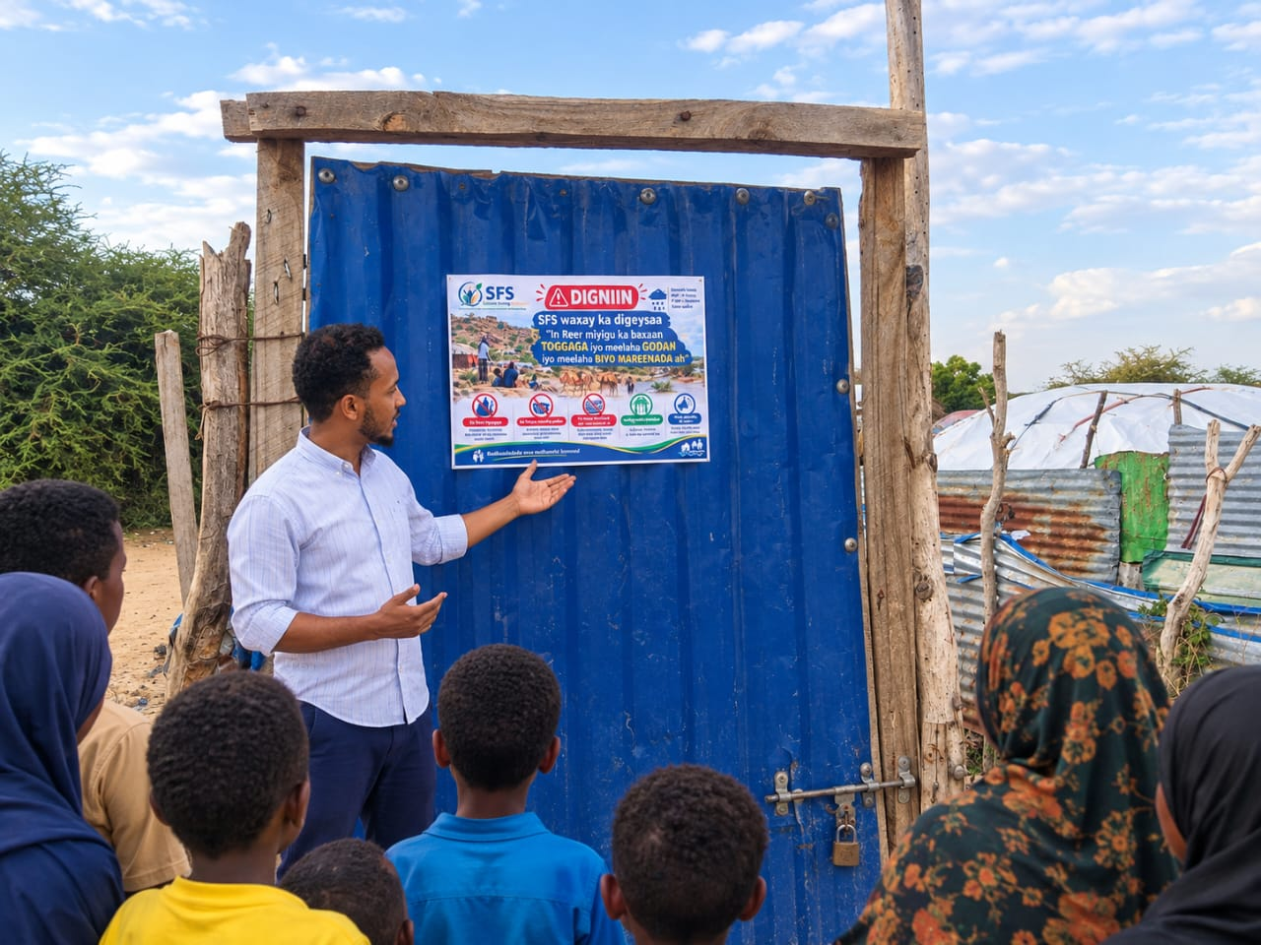
Photo 2. Flood safety messages are explained using the SFS awareness poster.

Photo documentation
Additional photographs from the campaign at Hodaan IDP Site.
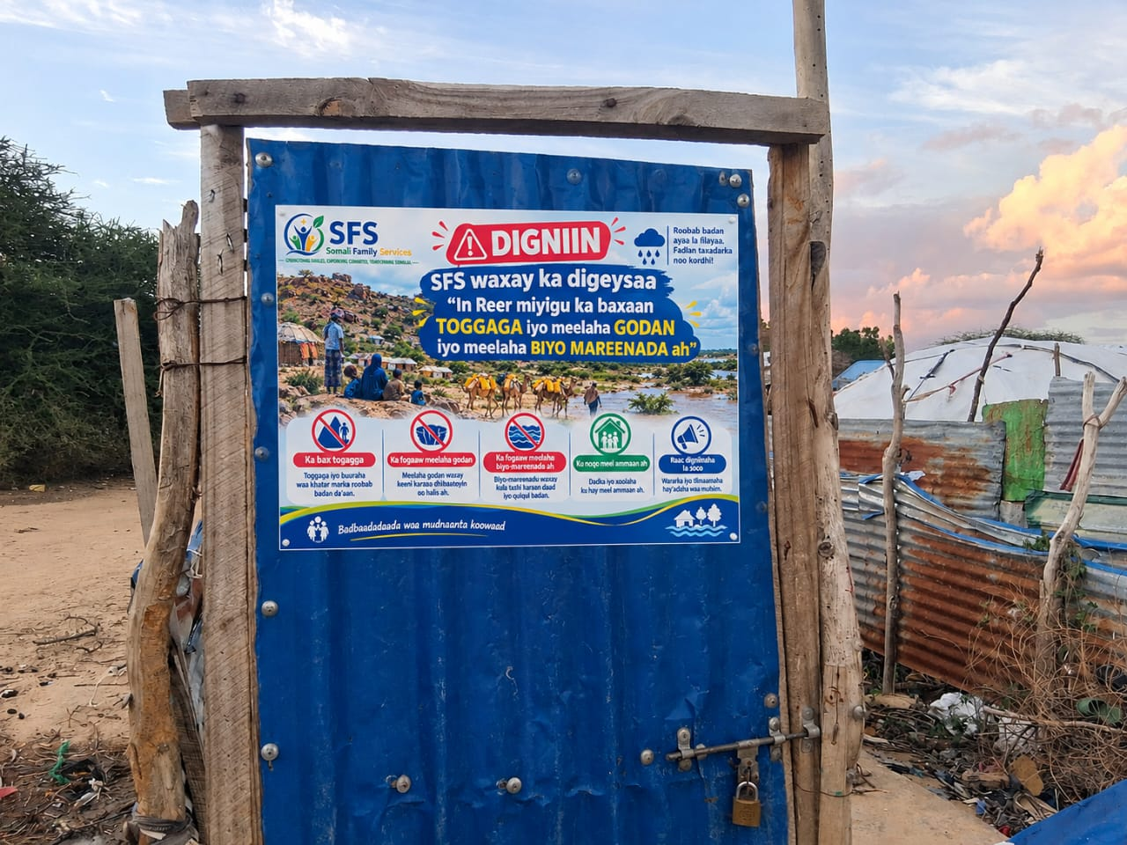
Photo 3. Somali-language SFS flood warning poster displayed within the site.
